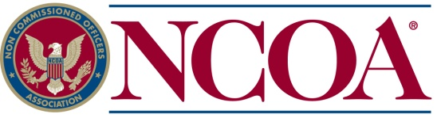

NCOA Awards Scholarships and Bettsy Ross Educational Grants

Selma, Texas – Five NCOA scholarships were recently awarded to dependents of NCOA members. NCOA Scholarships are initially awarded for one academic year, but the student may be considered to receive this assistance throughout four years of undergraduate study if the student maintains a "B" average, carries the prescribed minimum of 15 hours and submits the required renewal application.

Receiving NCOA scholarships for the 2022-23 school year are:

- Brady Burton, daughter of Marine Corps Veteran Corporal George and Pamela Burton of Charlotte, NC.

- Thomas Camp, son of CMSgt (USAF Ret) Ned and Joyce Seaman Clover, SC, FL, recipient of the E.L. “Ben” Benzel Distinguished Scholarship.

- Elisabeth M. Novak, daughter of SFC (USA Ret) Charles and Lisa Novak, of LaPointe, IN, recipient of the Walter W. Krueger Distinguished Scholarship.

- Rebekah Novak, daughter of SFC (USA Ret) Charles and Lisa Novak, of LaPointe, IN, recipient of the Walter W. Krueger Distinguished Scholarship.

- Keyon Trammel, daughter of MSG (USA Ret) Katara Trammel and Jermal Trammel, of Kempner, TX, recipient of the special Matthew Brzostowski Scholarship.

The NCOA Scholarship Fund has been providing grants to the children and spouses of NCOA members since 1975. To date more than $1.5 million dollars has been committed to educating tomorrow's leaders.

The NCOA International Auxiliary also awarded three Bettsy Ross Educational Grants in the amount of $500 each to Auxiliary members Ava Newberry of Oregon City, OR, Pamela Wright of Fair Oaks, CA, and Megan Ytzen of Colorado Springs, CO.

The Non Commissioned Officers Association (NCOA), a Military Service Organization (MSO), was created in 1960 to address quality of life issues for enlisted members of our Active, Reserve, National Guard, Retired, and Veteran members of all branches of the Armed Forces as well as their families. As we have evolved, education, work force development, employment, legislative advocacy and the quality of life within our communities as well as the physical and mental health of our enlisted service men and women and their families have become our primary aim.

